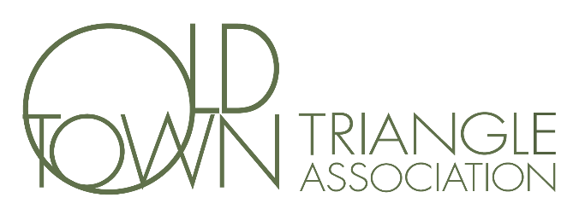

Minutes of the OTTA Members’ Annual Meeting
January 27, 2022

President Dorothy (Dee) DeCarlo called the meeting to order at 6:40 PM. Due to the COVID-19 pandemic and need for physical distancing, the meeting was a hybrid in-person and Zoom modality. A quorum was present.

Agenda items:

- Treasurer’s Report. Treasurer Brad Neuman reported on the Association’s finances. Brad noted that the finances associated with the 2021 OTAF exceeded projections and indicated that the OTAF was in a strong financial position.

- Committee Reports.

  - Art Fair. Anne Giffels provided a high-level recap of the 2021 OTAF, unveiled the poster for the 2022 OTAF, and shared updates on planning for the 2022 OTAF.

  - Bylaws. Chris Nelson shared that the OTTA bylaws are required to be reviewed every three years. A committee was assembled that reviewed and edited the bylaws. The updated bylaws were sent to OTTA members for review and then approved by the Board.

  - Community Safety. Sachi Kubo provided an update on efforts related to community safety, including details on the work two subcommittees have been engaged in over the past few months. Alderman Smith added additional details on efforts being taken related to community safety.

  - Events. Carly Jenkins highlighted events that occurred during 2021 and indicated plans for 2022 events, including more “micro” events that go beyond the traditional larger events (e.g., Oktoberfest) that the association holds.

  - HDPZ. Zac Bleicher reported on efforts related to the HDPZ committee, including discussion of current and future preservation issues the committee is working on.

- Special Project Discussion. Dee DeCarlo shared that the Board has allocated funds to be used for one or more special projects that are unrelated to the work of an existing Board committee. Suggestions had been elicited from members and four ideas that had received strong interest were presented and discussed: (1) plaques to be placed at the OTTA office, (2) revitalizing the entrance/front of the OTTA office, (3) development of an association strategic plan, and (4) purchase of OEMC cameras. Meeting attendees (both in person and Zoom) were asked to rate each topic on a four-point scale (strongly dislike, dislike, like, strongly like) to guide which idea(s) are prioritized.

- Election of 2022 Board Members. Darius Tandon, outgoing Secretary, shared the process used to generate the nominated 2022 Board Slate and introduced the individuals on the slate. A voice vote was taken to confirm the election of the following 2022 Board Members: Dorothy DeCarlo (President), Chris Nelson (Vice-President), Marya Lucas (Secretary), Brad Neuman (Treasurer), David Montgomery (Director), Alan Lougee (Director).

- Recognition of Retiring Directors. Outgoing Board members Shannon Waterfeld, Sachi Kubo, and Darius Tandon were presented with a trophy in recognition of their work on the Board.

- Adjournment. The meeting was adjourned at 8:45 PM

Respectfully submitted,
Darius Tandon
2021 OTTA Secretary

