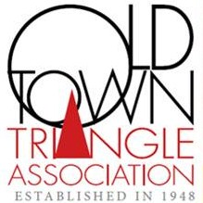

Please indicate if you have any of the symptoms listed below.
(People with COVID-19 have had a wide range of symptoms reported – ranging from mild symptoms to severe illness. Symptoms may appear 2-14 days after exposure to the virus.)

Do you have:
- Fever or chills
- Cough
- Shortness of breath or difficulty breathing
- Muscle or body aches
- Headache
- New loss of taste or smell
- Sore throat
- Congestion or runny nose
- Nausea or vomiting
- Diarrhea
This list does not include all possible symptoms. The CDC will continue to update this list as they learn more about COVID-19.
If you have checked yes to any of these questions; we ask that you return home and wait to return until 72 hours has passed without any additional symptoms.

Signature: _________________________________________________________________
Printed Name: ______________________________________________________________
Phone Number or email: ______________________________________________________
Date: _____________________________________________________________________

If anyone becomes ill while the OTTA is open, everyone who has been within the Center will be notified, all classes will be cancelled, and the Center will return to lockdown. If a second person becomes ill within 14 days, OTTA will notify the Chicago Department of Public Health and provide contact information for everyone who has entered the Triangle Center.
This form will be kept on file at the Old Town Triangle for six months.

