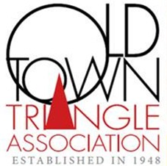

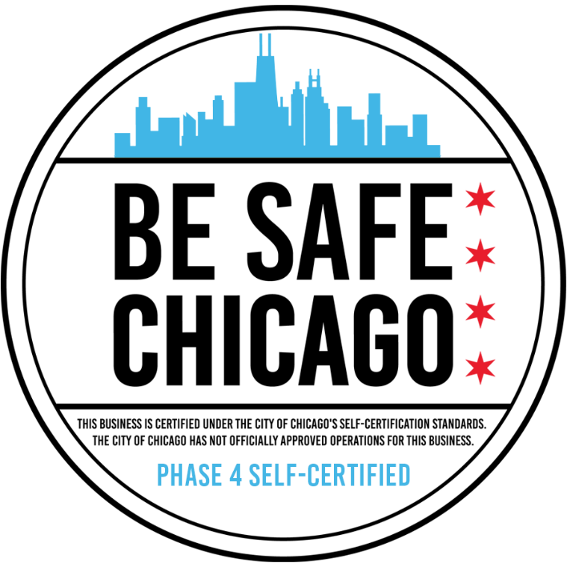

The Old Town Triangle Association applied for and received the self-certification Badge of Approval from the Chicago Department of Public Health.

