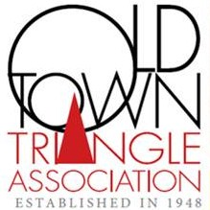

Old Town Triangle Center
Guidelines for re-opening

As the City and State move into Phase 4 of reopening, the Old Town Triangle Association will begin reopening in a more modest format. The OTTA will meet and exceed the guidelines for Phase 3 until further notice.
Anyone entering the Triangle Center will be required to wear a face mask and maintain it during the time they are inside. Within the entirety of the North Room (1763 N North Park) there can be no more than 10 people – with each person maintaining a six-foot distance from any other.

The OTTA will take the following preventative measures:
- Significantly limit class size, less than 50% of class capacity will be allowed,
- Masks will be required at all times,
- Sanitizing stations will be readily available throughout the room,
- Temporal thermometers will be used to ensure that no one entering has a fever. Anyone with a temperature of 100.4°F or above will not be permitted to remain on site,
- Only one class may meet per day,
- Cleanings will be scheduled to ensure that there is a thorough cleaning between each class,
- Art students and instructors will be required to affirm that they have no symptoms of COVID-19 and that they have not been in contact with anyone who has tested positive within the past 14 days,
- The communal kitchen will be closed, no coffee or refrigeration will be provided/accessible,
- Visual signage will be posted throughout regarding hygiene, social distancing, proper PPE and more,
- Doors and windows will remain open to increase ventilation.

