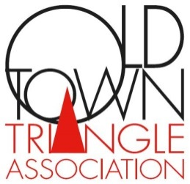
Art Class Registration
Fall classes September 5 – December 7
Please return with payment to complete registration process.

Classes Offered: Payment Information:
Monday: Name ____________________________________________ Figure Studio – 12 – 3 pm
Monitor – None Address__________________________________________
$140 Members
$145 Non-Members _________________________________________________
Drawing 6:30 – 9:30 pm City/State/Zip ____________________________________
Jeff Krantz

Tuesday: Phone (D) _______________________________________
Oil Painting – 10 am – 1 pm Phone (E) ________________________________________
Joe Taylor E-Mail ____________________________ @
Wednesday: ___________________________________ . __________
Pastel Painting -10 am – 1 pm
Kathleen Newman Total Payment $ ________________________
Oil Pastels – Sept 6 – Sept 27
1:30 – 4:30 pm $110/$105 Check Enclosed (Payable to: OTTA)
Didier Nolet Credit Card: Circle one: Visa MC Amex
Abstract Oil – Oct 4 – Nov 15 Exp: _____ / _____
1:30 – 4:30 pm $175/$165
Marie Kirk Burke Card # ___________________________________________
Evening Painting – 6:30 – 9:30 pm
Joe Taylor Signature: ________________________________________
Thursday: Send to: OTTA
Watercolor Painting 10 am – 1 pm 1763 N North Park Ave
Kathleen Newman Chicago IL 60614
Saturday:
Watercolor – 10 am – 1 pm
Tom Francesconi
~~~ All classes $245 Members/$255 Non-Members unless specified. ~~~

