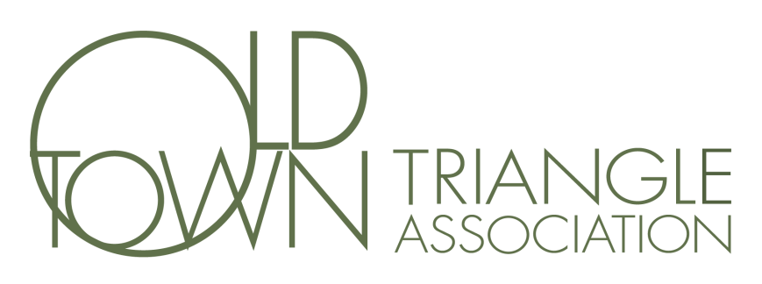
Minutes of the Annual Old Town Triangle Meeting
January 26, 2017
Steve Weiss called the meeting to order at 6:30 pm.
Board Members Present: Steve Weiss, Chris Huff, Jordan Matyas,, Shannon Waterfield, Claire Leaman, Dee DeCarlo, Chris Nelson and Karl Hjerpe.
Others Present: Dozens of OTTA Members.
President’s Report – Steve Weiss gave a summary of the previous year and showed a video montage.
Elections - Jordan Matyas discussed the nomination process and presented the slate of candidates that had been nominated which included
President (1 year term): Steve Weiss
1st Vice President (1 year term): Hans Pusch
Treasurer (1 year term): Christine Foushee Cardenas
Secretary (1 year term): Karen Pfendler
Director (3 year term): Jordan Matyas
Director (3 year term): Robert Jones
Dirk Vos made a motion to approve the candidates for the Board of the Old Town Triangle Association and David Pfendler seconded the motion. A vote was taken and all members voted Aye, there were no votes in opposition.
Motion to adjourn moved by Jordan Matyas at 7:45, Steve Weiss (2nd) passed unanimously.
Respectively Submitted,
Jordan Matyas
Secretary

