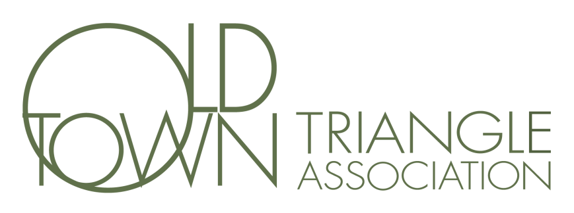
Minutes of the Board of Directors Meeting
February 9, 2016
Steve Weiss called the meeting to order at 7:08 pm.
Board Members Present: Steve Weiss, Chris Huff, Vi Daley, Jordan Matyas, Claire Leaman, Dee DeCarlo, Diane Gonzalez, Karl Hjerpe, Hans Pusch, Shannon Watterfield
Board Members Absent: Chris Nelson
Others Present: Rick Rausch, Lynn Smith, Diane Sokolofski, Nancy Jordan, Diane Fitzgerald, Michael Warnick, Leslie Wolfe, Barbara Guttmann
President’s Report: Steve Weiss talked about his goals for the year. His focus for the coming year is that we become a stronger community of friends and integrate kids into all programs.
Approval of December, January Executive Session and regular January meeting minutes: Karl Hjerpe (Motion) Diane Gonzalez (2nd) passed unanimously.
Treasurer’s Report: Claire Leaman reported on the state of the budget.
Newsletter Report – Diane Fitzgerald gave a presentation on the current state of the newsletter and the plans for the coming year. All the volunteers were introduced. Further discussion needs to take place as the current volunteers will turn over the leadership of the newsletter at the end of the year.
Standing Committee Reports:
Steve Weiss motioned for the approval of the 2016 committees and chairs. Chris Huff (2nd) and motion passed unanimously.
Art Fair: Vi Daley discussed the current partnerships with restaurants. There was discussion and agreement that the entry donation should be increased from $7 to $10 and that all kids should enter for free.
Capital Improvements Committee: Window work is nearly complete. Brick work has been delayed until the spring.
Events: Steve Weiss discussed a number of events including: March 20 an Easter event, May 1 a play will be produced, September – BBQ contest, October Mac and Cheese contest, Kids Art Show, Progressive dinner.
HD/PZ – Karl Hjerpe discussed a pending hearing regarding a property on Menomonee that will be held at City hall in March. Committee wants to be more positive and not just refusing projects. Unveiled new web program with pictures and new maps.
Marketing – A new survey will be sent out in the coming weeks.
Youth Committee – Steve Weiss discussed his desire to engage the youth in all aspects of the organization.
Old Business: None
New Business: None
Motion to adjourn moved by Steve Weiss at 9:06 pm, Jordan Matyas (2nd) passed unanimously.
Meeting adjourned.
Respectively Submitted,

Jordan Matyas
Secretary

